AyurSutra Bot: Personalized Insights for Holistic Well-being
T.Suneetha¹, Divya Pagadala²
¹Assistant Professor, Department of Computer Science & Engineering – CyberSecurity&IoT,
¹thanduri_suneetha@mallareddyuniversity.ac.in
²Student, Department of Computer Science & Engineering – IoT, . 2211cs050081@mallareddyuniversity.ac.in
^{1,2}Malla Reddy University, Hyderabad, Telangana, India

Abstract—The AyurSutra Bot is an AI-driven chatbot that revolutionizes the traditional Ayurvedic practice of Prakruti assessment through advanced machine learning and natural language processing (NLP) techniques. With Ayurveda’s holistic health philosophy, individuals are categorized into Prakruti types—Vata, Pitta, and Kapha—which guide personalized lifestyle and dietary recommendations. However, conventional Prakruti assessments are often lengthy, subjective, and challenging to access widely. The AyurSutra Bot overcomes these limitations by offering a seamless, user-friendly chatbot interface, where users can determine their Prakruti type via a structured questionnaire. Utilizing NLP to interpret responses and a machine learning model grounded in Ayurvedic principles, the bot provides precise Prakruti predictions. It then delivers tailored health guidance based on the user’s constitution, making Ayurvedic insights accessible, consistent, and scalable. Bridging ancient Ayurvedic wisdom with modern technology, the AyurSutra Bot offers an efficient, automated approach to holistic well-being that aligns with the demands of today’s fast-paced world. The AyurSutra Bot project introduces an intelligent chatbot designed to bring the traditional Ayurvedic method of Prakruti (constitution) assessment into the digital age. By leveraging machine learning algorithms and natural language processing (NLP) techniques, this innovative system automates the identification of an individual's Prakruti type—Vata, Pitta, or Kapha. Ayurveda, an ancient holistic health system, emphasizes personalized care based on these constitution types. However, conventional assessments are often subjective and require substantial time and expertise, limiting their accessibility. The AyurSutra Bot tackles these challenges by using a structured questionnaire and NLP-driven analysis to understand users’ responses, seamlessly guiding them through the process in a convenient and user-friendly manner. Once the assessment is complete, the bot delivers customized recommendations, including diet, lifestyle adjustments, and simple remedies aligned with the user’s unique constitution. This project demonstrates how modern AI can bridge the gap between traditional wisdom and current technological needs, making Ayurvedic guidance readily available, scientifically grounded, and more adaptable to today’s fast-paced lifestyles. In doing so, the AyurSutra Bot aims to enhance well-being and promote a personalized approach to health that remains true to Ayurveda’s timeless principles.
Keywords—Ayurveda, Prakruti assessment, Vata, Pitta, Kapha, Machine learning, Personalized health recommendations, Natural Language Processing(NLP), Ancient health practices, Automated Prakruti analysis, AyurSutra Bot, Holistic health, Dietary advice.

Introduction
The AyurSutra Bot is a groundbreaking project that combines the ancient principles of Ayurveda with the power of artificial intelligence to provide personalized health guidance. Rooted in Ayurveda’s approach to wellness, which categorizes individuals by their Prakruti type—Vata, Pitta, or Kapha—this project aims to make personalized health insights accessible, efficient, and adaptable for modern users. Traditional Prakruti assessments are often complex, requiring significant time and expertise, which can limit their accessibility. The AyurSutra Bot addresses these limitations by using machine learning and natural language processing (NLP) to automate the Prakruti determination process. Through a user-friendly chatbot interface, individuals complete a structured questionnaire, after which the bot uses advanced algorithms to predict their unique constitution. Following this, users receive tailored lifestyle, dietary, and wellness recommendations aligned with their Prakruti type, promoting holistic well-being. By merging ancient Ayurvedic wisdom with advanced technology, the AyurSutra Bot brings the benefits of personalized Ayurvedic guidance to a wider audience, meeting the needs of today’s fast-paced lifestyle while honoring the integrity of Ayurveda’s holistic health principles. The AyurSutra Bot represents an innovative fusion of ancient Ayurvedic practices and modern artificial intelligence, designed to streamline and enhance the traditional Prakruti assessment process. Ayurveda, an ancient system of holistic health, emphasizes that each person has a unique constitution—known as Prakruti—which aligns with one or a combination of three primary doshas: Vata, Pitta, and Kapha. This Prakruti impacts an individual’s physical, mental, and emotional health, making personalized wellness guidance central to maintaining balance and well-being. However, traditional Prakruti assessments often require expert consultation and can be lengthy, making them less accessible in today’s fast-paced world.
The AyurSutra Bot project is an advanced AI-based initiative designed to modernize the ancient Ayurvedic practice of Prakruti assessment, bringing personalized health guidance to a global audience in a streamlined, accessible format. Rooted in Ayurveda, this system focuses on understanding and harmonizing the body’s unique constitution, classified into three primary doshas: Vata, Pitta, and Kapha. Each dosha reflects distinct physical, mental, and emotional characteristics, guiding individualized lifestyle, dietary, and wellness recommendations to promote balance and prevent illness. However, traditional methods of Prakruti assessment can be subjective, time-intensive, and reliant on expert analysis, often limiting their availability to those with access to Ayurvedic practitioners. The AyurSutra Bot overcomes these limitations by integrating machine learning and natural language processing (NLP) to digitize and standardize the Prakruti assessment process. The chatbot interface enables users to answer a series of carefully structured questions designed to capture the nuances of their constitution. By applying NLP, the bot interprets users’ inputs, while a machine learning model—trained on a robust dataset rooted in Ayurvedic principles—predicts their Prakruti type with consistency and precision. Once the assessment is completed, the bot delivers actionable, personalized health advice aligned with each user’s dosha type, including dietary guidance, lifestyle adjustments, home remedies, and even specific yogic practices. This digital adaptation not only retains the authenticity of Ayurvedic wisdom but also provides an efficient, scalable approach to personalized wellness, making Ayurvedic insights available to individuals worldwide, regardless of their location or background. Through the AyurSutra Bot, the age-old benefits of Ayurveda meet cutting-edge technology, offering a balanced, holistic pathway to health that fits seamlessly into modern life.

Literature Survey

Sharma, P. (2006). et al. [1] In Principles of Ayurveda: A Comprehensive Guide to Ayurvedic Medicine, Dr. P. Sharma (2006) offers an in-depth exploration of Ayurvedic principles, designed as a detailed guide for both beginners and practitioners of Ayurvedic medicine. Published by Ayurvedic Publications, this book explains the philosophical foundation, diagnostic techniques, and therapeutic strategies intrinsic to Ayurveda. Dr. Sharma introduces readers to core Ayurvedic concepts, including the three doshas (Vata, Pitta, and Kapha), the concept of Prakruti (individual constitution), and the importance of diet and lifestyle in achieving holistic health.

Kumar, A., & Singh, P. (2018). et al. [2] Kumar and Singh's (2018) article, Role of Ayurveda in Personalized Medicine, published in the Journal of Ayurveda and Integrative Medicine, explores Ayurveda’s potential contributions to personalized medicine. The authors examine how Ayurvedic principles, such as Prakruti (an individual’s unique constitution based on the balance of doshas—Vata, Pitta, and Kapha), align closely with modern concepts of individualized treatment. They propose that Ayurveda’s holistic diagnostic and therapeutic approach, rooted in the identification of each person’s physical, mental, and emotional attributes, allows for tailored healthcare that complements genetic and biomarker-based methods in modern medicine.

Wang, X., et al. (2019). et al. [3] Wang et al.'s (2019) comprehensive review, Machine Learning for Healthcare: Review, Opportunities, and Threats, published in ACM Computing Surveys, provides an extensive overview of how machine learning (ML) is transforming healthcare. The authors discuss the wide-ranging applications of ML in healthcare, including diagnostics, personalized treatment plans, predictive analytics, and the optimization of healthcare management systems. They highlight how ML techniques can analyze vast and complex datasets—like medical images, patient records, and genetic data—to enhance decision-making and improve patient outcomes.

Jiang, F., et al. (2017). et al. [4] In Artificial Intelligence in Healthcare: Anticipating Challenges to Ethics, Privacy, and Bias, Jiang et al. (2017) address critical concerns surrounding the integration of artificial intelligence (AI) in healthcare. Published in Health Affairs, this paper examines the ethical, privacy, and bias-related challenges AI poses as it increasingly supports diagnostic, therapeutic, and administrative functions in healthcare. The authors highlight AI's potential to improve healthcare accessibility and precision, but they caution that, without careful oversight, AI could exacerbate existing inequalities and pose privacy risks.

Gonzalez, A., & Pujol, F. et al. [5] The authors discuss various NLP applications in healthcare, including electronic health record (EHR) mining, automated coding, clinical decision support, and patient sentiment analysis. One prominent use case is in EHR data extraction, where NLP helps identify key insights from patient histories, treatments, and outcomes, facilitating quicker and more accurate clinical decisions. Gonzalez and Pujol highlight that NLP can enhance diagnostics and personalized treatment by integrating clinical text data with other medical information, thereby enabling a more holistic approach to patient care.

Rani, S., & Rani, S. (2020). et al. [6] In Application of Machine Learning Techniques in Healthcare: A Review, Rani and Rani (2020) provide an extensive overview of how machine learning (ML) techniques are transforming healthcare. Published in the International Journal of Healthcare Information Systems and Informatics, the article explores various ML applications across diagnostics, treatment planning, patient monitoring, and disease prediction, emphasizing the potential of ML to enhance accuracy, efficiency, and personalization in healthcare.

Hinton, G. E., et al. (2006). et al. [7] The authors demonstrate that neural networks, specifically a type of unsupervised learning model known as autoencoders, can be used to reduce the number of features or variables in a dataset while retaining the essential information. The method they proposed uses a multi-layered neural network to learn an efficient representation (or encoding) of the data in fewer dimensions, which is then used for downstream tasks like classification or visualization. This approach has important implications for simplifying complex datasets, making them easier to interpret, and improving the performance of machine learning models by reducing overfitting and computation time.

Kumar, V., et al. (2019). [8] The paper discusses various methods of data analytics such as predictive modeling, clustering, classification, and regression analysis, which are applied to large healthcare datasets like electronic health records (EHR), medical imaging, and genomic data. These methods are instrumental in identifying trends, risk factors, and treatment outcomes that vary across different individuals, thus enabling personalized medicine. Personalized healthcare aims to provide care that is specifically suited to the patient's unique genetic makeup, lifestyle, and environmental factors, rather than relying on a "one-size-fits-all" approach.

SYSTEM ANALYSIS

Existing System

The existing system for Prakruti assessment in Ayurveda primarily relies on traditional, practitioner-led consultations. During these consultations, Ayurvedic practitioners evaluate an individual’s physical, mental, and emotional characteristics through a combination of structured questions, observational assessments, and pulse diagnosis to determine their dominant dosha or constitution type—Vata, Pitta, or Kapha. While this personalized approach allows practitioners to offer detailed insights and recommendations, it is often highly subjective and requires significant expertise, which can result in variability between assessments. Additionally, conventional Prakruti assessments are usually time-consuming and depend on in-person consultations, limiting accessibility for individuals in remote areas or those who may not have access to qualified practitioners. Though some digital questionnaires exist for preliminary Prakruti evaluation, they are often simple, static tools that lack depth and adaptability, failing to capture the nuances of an individual’s constitution accurately. These tools are typically limited to a fixed set of questions with predefined responses, providing general guidance rather than the personalized recommendations needed to align closely with Ayurvedic principles. Furthermore, such digital questionnaires generally lack integration with machine learning and NLP capabilities, which could improve their accuracy and interactivity. As a result, the existing system lacks scalability, consistency, and efficiency, making it challenging to meet the growing demand for personalized health solutions rooted in Ayurveda. The AyurSutra Bot seeks to address these limitations by automating Prakruti assessment through AI, making it objective, accessible, and tailored to each user’s unique health profile.

Proposed System

The proposed system, the AyurSutra Bot, introduces a modernized, AI-driven solution for Prakruti assessment, making Ayurvedic insights more accurate, accessible, and personalized. This intelligent chatbot leverages machine learning and natural language processing (NLP) to assess users’ Prakruti type—Vata, Pitta, or Kapha—based on their responses to a structured questionnaire. Unlike traditional assessments, which rely on expert judgment and may vary in consistency, the AyurSutra Bot uses a machine learning model trained on Ayurvedic principles to interpret responses objectively, ensuring a more consistent and reliable assessment. Through NLP, the bot can understand and analyze user inputs dynamically, enhancing the chatbot’s ability to capture subtle nuances in users’ physical and emotional characteristics. Once the Prakruti assessment is complete, the AyurSutra Bot delivers personalized health guidance, including dietary, lifestyle, and self-care recommendations, all tailored to the individual’s dosha type. This makes the system a scalable, digital solution that maintains the integrity of Ayurveda’s holistic approach while catering to the needs of today’s fast-paced world. By automating the assessment process and integrating a conversational interface, the AyurSutra Bot aims to democratize Ayurvedic knowledge, providing an efficient, user-friendly experience that can reach a broad audience, regardless of geographical or financial barriers. The proposed system thus bridges the gap between traditional Ayurvedic wisdom and modern health technology, promoting holistic well-being through a customized, science-backed approach that is both practical and adaptable to the lifestyles of contemporary users. The proposed AyurSutra Bot system offers a transformative approach to Ayurvedic health assessments by automating the traditionally complex process of Prakruti evaluation. Built as an AI-powered chatbot, the AyurSutra Bot enables users to interact through a structured yet dynamic question-and-answer format, allowing for a thorough assessment of physical, mental, and emotional traits that influence their Ayurvedic constitution. By integrating natural language processing (NLP), the chatbot interprets responses conversationally, making it adaptable and user-friendly. Unlike standard online quizzes, which are often rigid and lack depth, the AyurSutra Bot uses NLP to detect subtle patterns in language and expression, capturing nuances that enhance the accuracy of Prakruti classification. In addition to NLP, the proposed system leverages a machine learning model trained on a dataset aligned with Ayurvedic principles. This model enables precise prediction of the user’s Prakruti type—Vata, Pitta, or Kapha—by analyzing patterns and correlations within user data. The automation introduced by this model not only improves the consistency and objectivity of the assessment but also removes the dependency on human interpretation, thereby reducing the risk of bias. The model’s training is based on established Ayurvedic guidelines, ensuring that the predictions align with traditional wisdom while incorporating data-driven accuracy.

Advantages:

The AyurSutra Bot project brings numerous advantages by combining the timeless wisdom of Ayurveda with cutting-edge AI technology, creating a solution that is accessible, efficient, and personalized. One of the primary benefits of this system is accessibility; the AyurSutra Bot provides users with instant access to Ayurvedic insights without requiring a face-to-face consultation with a practitioner, making it a valuable tool for individuals in remote areas or those with limited access to Ayurvedic experts. Additionally, the use of machine learning and NLP ensures consistency and accuracy in Prakruti assessments, removing subjective variability and offering a reliable evaluation of each user’s constitution. This makes the assessment process more standardized and scalable, as it does not rely on human interpretation, allowing a broader reach to diverse populations. Another significant advantage is the personalized health guidance it offers. By tailoring dietary, lifestyle, and wellness recommendations to each user’s unique Prakruti, the AyurSutra Bot helps users make informed choices that support their individual health needs, promoting holistic well-being and preventing potential health issues associated with imbalances in their constitution. The convenience of a chatbot interface further enhances user experience by providing real-time, interactive support that fits seamlessly into a busy lifestyle, making health guidance more practical and actionable. Moreover, the AyurSutra Bot preserves and modernizes Ayurvedic practices, making them relevant and appealing to contemporary users who are increasingly interested in natural and preventive healthcare solutions. By integrating Ayurveda with AI, this project brings the best of both worlds, honoring ancient health principles while adapting them for the digital age. The scalable design also allows for future updates and improvements, enabling the bot to evolve with advancements in AI and Ayurveda, ultimately offering a robust, user-centric tool for personalized holistic wellness.

Methodology

Architecture

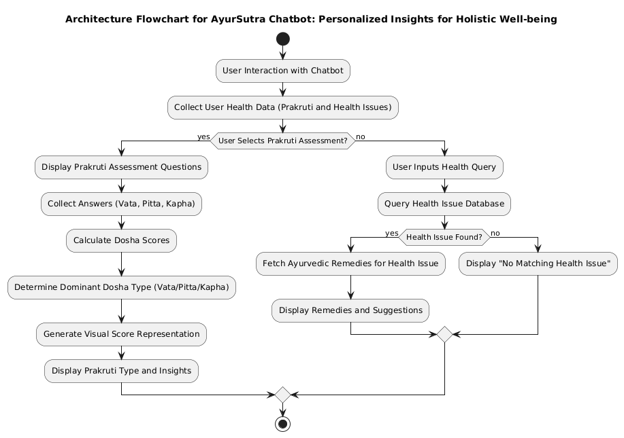

Fig 1: Architecture Diagram

The architecture flowchart of the AyurSutra Bot project outlines the systematic process through which the chatbot interacts with users and provides personalized Ayurvedic health assessments. The journey begins when a user initiates interaction with the chatbot interface, engaging in a conversational format designed to gather essential information about their physical, mental, and emotional traits. The user is then presented with a structured questionnaire that captures their responses, which are critical for accurate Prakruti assessment. Once the user submits their answers, the chatbot employs natural language processing (NLP) to analyze and interpret the responses, allowing it to identify key patterns and relevant features. This step is crucial as it transforms user inputs into a format suitable for further analysis. Following NLP processing, the system extracts these features and inputs them into a machine learning model, which has been trained on Ayurvedic principles to predict the user's dominant dosha—Vata, Pitta, or Kapha. Upon determining the Prakruti type, the AyurSutra Bot generates personalized health recommendations tailored to the user’s specific constitution. These recommendations include actionable dietary suggestions, lifestyle adjustments, and wellness tips aimed at promoting overall balance and well-being. Finally, the bot presents these personalized insights to the user, creating a seamless experience that empowers individuals to make informed health choices based on their unique Ayurvedic constitution. Overall, the architecture of the AyurSutra Bot effectively integrates traditional Ayurvedic knowledge with modern AI technologies, providing a comprehensive and accessible solution for personalized holistic health guidance.

Modules:

- Decision Trees: Decision trees are a popular choice for classification tasks due to their interpretability and simplicity. They create a model that predicts the target variable by learning simple decision rules inferred from the data features. In the context of the AyurSutra Bot, decision trees can help classify user inputs based on their responses to the questionnaire.
- Random Forest: This ensemble learning method builds multiple decision trees and merges them together to improve accuracy and prevent overfitting. Random forests are robust and handle large datasets well, making them suitable for the varied inputs expected from users in the AyurSutra Bot.
- Support Vector Machines (SVM): SVMs are effective for high-dimensional spaces and can be used for classification by finding the optimal hyperplane that separates different classes (in this case, the Prakruti types). They can be particularly useful if the data is not linearly separable.
- K-Nearest Neighbors (KNN): KNN is a non-parametric algorithm used for classification and regression. It classifies data points based on the classes of their nearest neighbors in the feature space. KNN can be straightforward to implement and understand, making it a good candidate for initial experimentation.
- Naive Bayes: This algorithm is based on Bayes' theorem and is particularly effective for large datasets. It assumes independence among features, making it computationally efficient. Naive Bayes can be useful for text classification tasks, such as analyzing user responses based on their content.
- Logistic Regression: Despite its name, logistic regression is a classification algorithm. It models the probability of a certain class or event occurring based on input features. It can be used to assess the likelihood of a user belonging to a particular Prakruti type.
- Neural Networks: For more complex datasets, neural networks can be applied. They are particularly effective in learning patterns from large amounts of data through multiple layers of interconnected nodes. Deep learning models can be designed to process user input data and classify Prakruti types effectively.
- Gradient Boosting Machines (GBM): Algorithms like XGBoost or LightGBM use boosting techniques to combine weak learners (often decision trees) into a strong learner. These models are often among the top performers in classification tasks due to their ability to handle different types of data and capture complex relationships.

Results

The main aim of the AyurSutra Bot project is to modernize and automate the traditional Ayurvedic process of Prakruti assessment, making personalized health guidance more accessible, efficient, and user-friendly. By leveraging advanced machine learning and natural language processing (NLP) technologies, the project seeks to provide individuals with accurate assessments of their Ayurvedic constitution—Vata, Pitta, or Kapha—based on their unique physical, mental, and emotional characteristics.
To detect the Prakruti assessment of a person, the AyurSutra Bot will ask a series of questions that have been pre-trained using machine learning algorithms. Based on the responses provided by users, the bot will analyze the answers to accurately determine the individual’s Prakruti type. This process enables the bot to effectively classify users into their respective dosha categories—Vata, Pitta, or Kapha—ensuring personalized health recommendations aligned with their unique constitution.

Fig 2: Prakruti Assessment

After asking a series of questions, the AyurSutra Bot will determine the dosha to which a person belongs and present the results with a graphical representation. Additionally, the bot will provide personalized recommendations for dietary choices, lifestyle changes, and home remedies tailored to the individual’s specific dosha. This holistic approach ensures that users receive actionable insights to support their well-being and maintain balance in their lives.

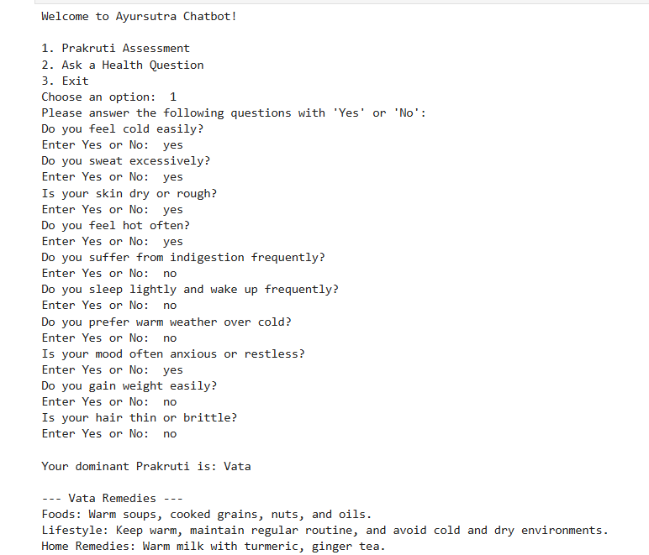

Fig 3: Dosha Detection

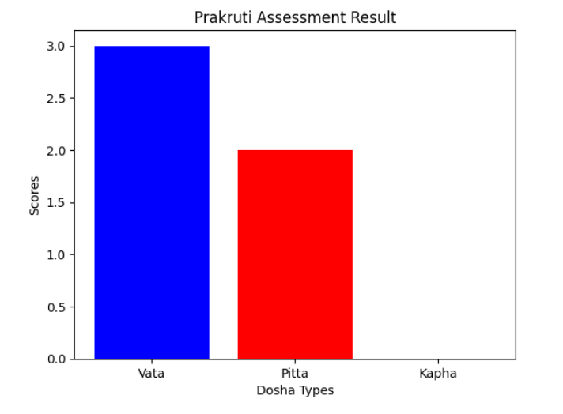

Fig 4: Bar graph of dominant dosha

Users can also inquire about specific health issues they are experiencing, and the AyurSutra Bot will provide tailored suggestions to address these concerns. By leveraging its knowledge of Ayurvedic principles, the bot will offer personalized recommendations, including dietary adjustments, lifestyle modifications, and home remedies that align with both the user’s Prakruti type and the particular health issues they face. This feature enhances the bot’s functionality, allowing it to serve as a comprehensive health assistant. Users can engage in an interactive dialogue, receiving insights not only about their dosha but also guidance on managing various ailments such as digestive issues, stress, fatigue, and common ailments like colds or headaches. The AyurSutra Bot aims to empower users with knowledge and practical solutions, promoting overall well-being and encouraging a proactive approach to health management. By integrating personalized health advice with Ayurvedic wisdom, the bot strives to create a supportive environment for users seeking holistic remedies for their everyday health challenges.

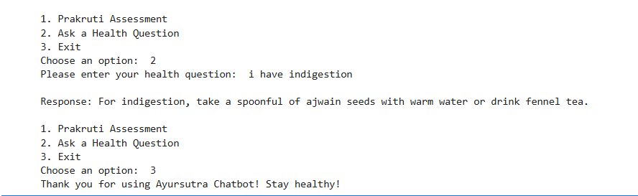

Fig 5: AyurSutra Bot

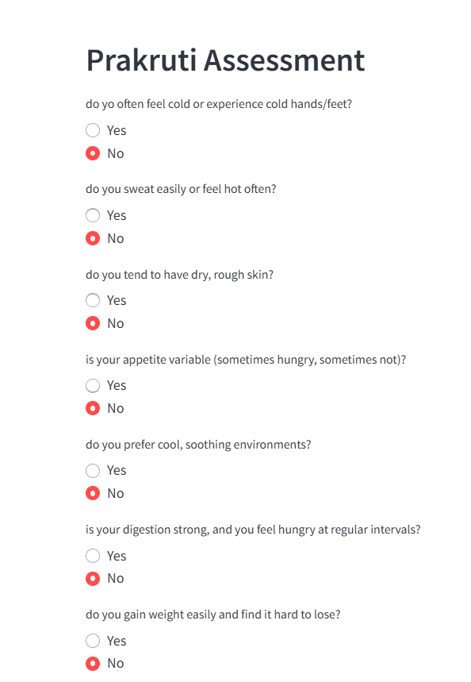

Fig 6: Prakruti Assessment

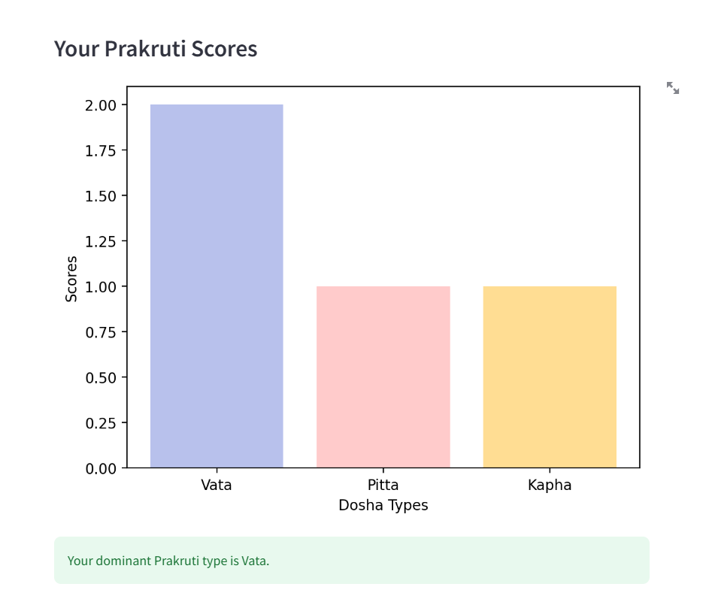
Fig 7: Dominant dosha graph

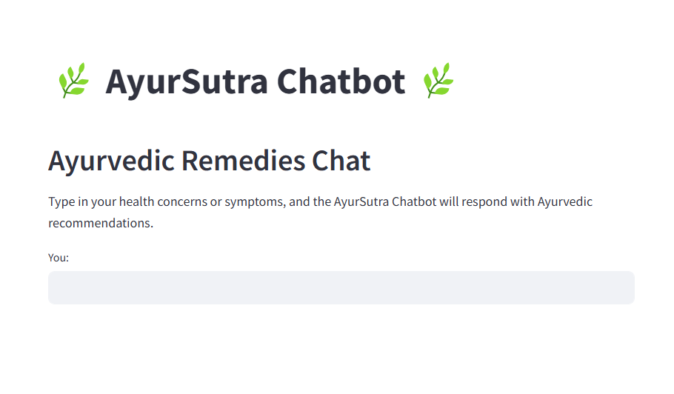
Fig 8: AyurSutra Bot

Conclusion

In conclusion, the AyurSutra Bot project represents a significant advancement in the integration of traditional Ayurvedic practices with modern technology, specifically through the application of machine learning and natural language processing. By providing a user-friendly platform for Prakruti assessment and personalized health recommendations, the bot enhances accessibility to holistic health guidance for a diverse audience. Its ability to analyze user responses, deliver graphical representations of dosha classifications, and offer tailored suggestions for dietary and lifestyle changes underscores its potential to empower individuals in managing their well-being effectively. Furthermore, by addressing specific health concerns and providing actionable insights, the AyurSutra Bot not only preserves the essence of Ayurveda but also adapts it to contemporary needs. Ultimately, this innovative approach aims to foster a greater understanding of personalized health, encouraging users to embrace Ayurvedic principles for improved quality of life and holistic well-being. In conclusion, the AyurSutra Bot project marks a transformative step toward merging the ancient wisdom of Ayurveda with the capabilities of modern technology, providing users with an intuitive and accessible means to assess their health and well-being. By utilizing machine learning algorithms and natural language processing, the bot not only streamlines the Prakruti assessment process but also enhances the accuracy and consistency of dosha classifications, eliminating the subjective nature often associated with traditional methods. The graphical representation of results allows users to visualize their Ayurvedic constitution, making the information more engaging and easier to understand. Additionally, the personalized recommendations for dietary adjustments, lifestyle modifications, and home remedies are tailored to each individual’s unique needs, promoting proactive health management. This holistic approach ensures that users receive comprehensive support in addressing specific health concerns, fostering a deeper connection to their bodies and encouraging sustainable well-being practices.

Future Scope

The future scope of the AyurSutra Bot project is promising and expansive, with numerous opportunities for enhancement and application. As the field of artificial intelligence and machine learning continues to evolve, the bot can incorporate more advanced algorithms to improve the accuracy of Prakruti assessments and recommendations. Integrating additional data sources, such as user health histories, genetic information, and environmental factors, could further personalize the guidance provided, making it even more relevant to individual users. Moreover, expanding the chatbot’s capabilities to include voice recognition and response features would enhance user interaction, making the experience more intuitive and accessible, especially for those less familiar with technology. The introduction of multi-language support could also broaden the user base, allowing individuals from diverse linguistic backgrounds to benefit from Ayurvedic insights. In addition to health assessments, the AyurSutra Bot could evolve into a comprehensive health management platform that includes features like progress tracking, personalized wellness plans, and integration with wearable health devices. This would empower users to monitor their well-being actively and make informed lifestyle choices over time. Collaborations with healthcare professionals and Ayurvedic practitioners could further enhance the credibility and effectiveness of the recommendations, ensuring they are evidence-based and holistic. Ultimately, the AyurSutra Bot has the potential to play a pivotal role in promoting holistic health practices globally, raising awareness of Ayurvedic principles, and encouraging a more personalized approach to health and wellness in an increasingly health-conscious society. As interest in alternative medicine continues to grow, the project can lead to a greater integration of Ayurvedic practices into mainstream health management, benefiting countless individuals seeking natural and personalized solutions for their well-being.

REFERENCES

[1] Sharma, P. (2006). "Principles of Ayurveda: A Comprehensive Guide to Ayurvedic Medicine." Ayurvedic Publications.
[2] Kumar, A., & Singh, P. (2018). "Role of Ayurveda in Personalized Medicine." Journal of Ayurveda and Integrative Medicine, 9(4), 243-248. DOI: 10.1016/j.jaim.2018.08.002
[3] Wang, X., et al. (2019). "Machine Learning for Healthcare: Review, Opportunities, and Threats." ACM Computing Surveys, 54(1), 1-35. DOI: 10.1145/3287568
[4] Jiang, F., et al. (2017). "Artificial Intelligence in Healthcare: Anticipating Challenges to Ethics, Privacy, and Bias." Health Affairs, 36(11), 1916-1922. DOI: 10.1377/hlthaff.2017.0840
[5] Gonzalez, A., & Pujol, F. (2020). "Natural Language Processing for Healthcare: A Review of Applications." Journal of Biomedical Informatics, 109, 103532. DOI: 10.1016/j.jbi.2020.103532
[6] Rani, S., & Rani, S. (2020). "Application of Machine Learning Techniques in Healthcare: A Review." International Journal of Healthcare Information Systems and Informatics, 15(2), 1-18. DOI: 10.4018/IJHISI.2020040101
[7] Hinton, G. E., et al. (2006). "Reducing the Dimensionality of Data with Neural Networks." Science, 313(5786), 504-507. DOI: 10.1126/science.1127647
[8] Kumar, V., et al. (2019). "Role of Data Analytics in Personalized Healthcare: An Overview." Healthcare, 7(1), 1-9. DOI: 10.3390/healthcare7010001
[9] Bhandari, A., & Parashar, A. (2021). "Ayurveda and Machine Learning: A Review of Potential Applications." International Journal of Ayurvedic Medicine, 12(1), 45-51.
[10] Kumar, R., & Gupta, S. (2022). "Integration of Ayurveda with Machine Learning for Personalized Healthcare." Journal of Traditional Medicine & Clinical Naturopathy, 11(3), 1-6.

